Kubernetes Documentation

Overview

<https://www.ais.com/an-overview-of-kubernetes-architecture-and-container-deployment/>

Kubernetes Setup in cloud

<https://labs.play-with-k8s.com/>

Copy paste shortcuts:

* COPY - CTRL+INSERT or CTRL+FN+INSERT
* PASTE - SHIFT+CTRL+V

Kubernetes setup in Centos Documentation:

*https://www.tecmint.com/install-kubernetes-cluster-on-centos-7/*

Kubernetes Initialization

kubeadm init --apiserver-advertise-address $(hostname -i) --pod-network-cidr 10.5.0.0/16

kubectl apply -f <https://raw.githubusercontent.com/cloudnativelabs/kube-router/master/daemonset/kubeadm-kuberouter.yaml>

kubectl apply -f <https://raw.githubusercontent.com/kubernetes/website/master/content/en/examples/application/nginx-app.yaml>

References

Kubernetes kubectl reference docs

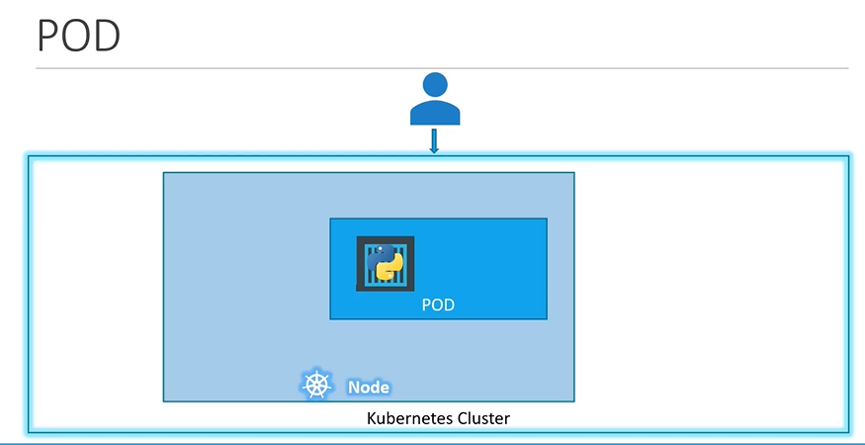

kubectl create -f pod.yaml

kubectl get pods

kubectl get all

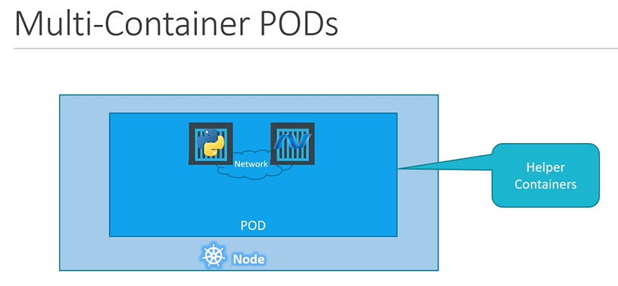

ReplicaSets

Replication controller – Older

Replicasets - Newer

